**JTAG Protection Steps**

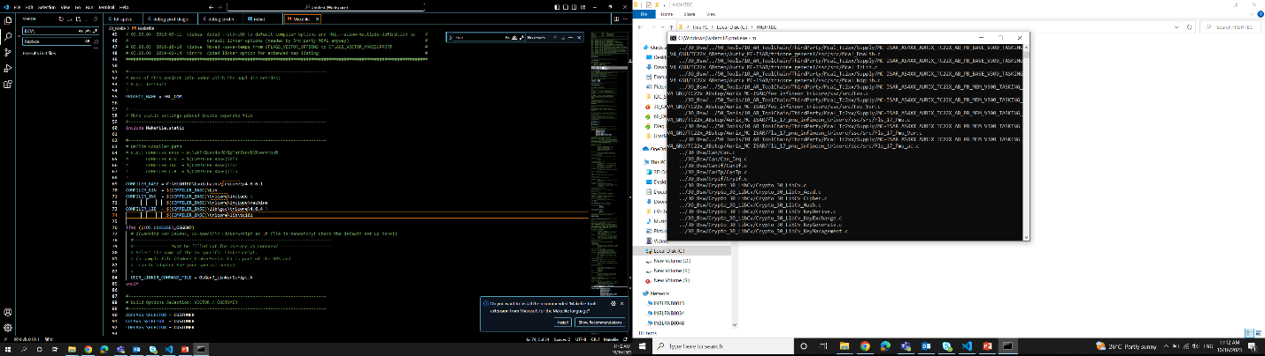

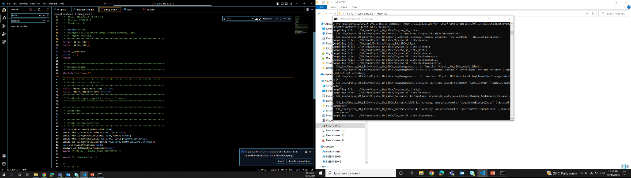

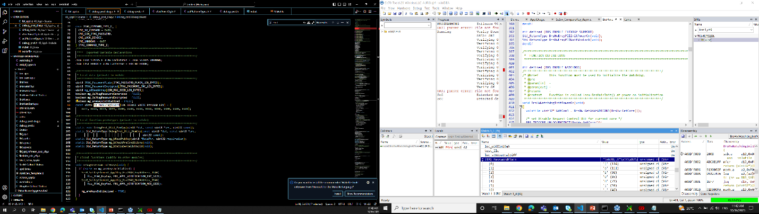

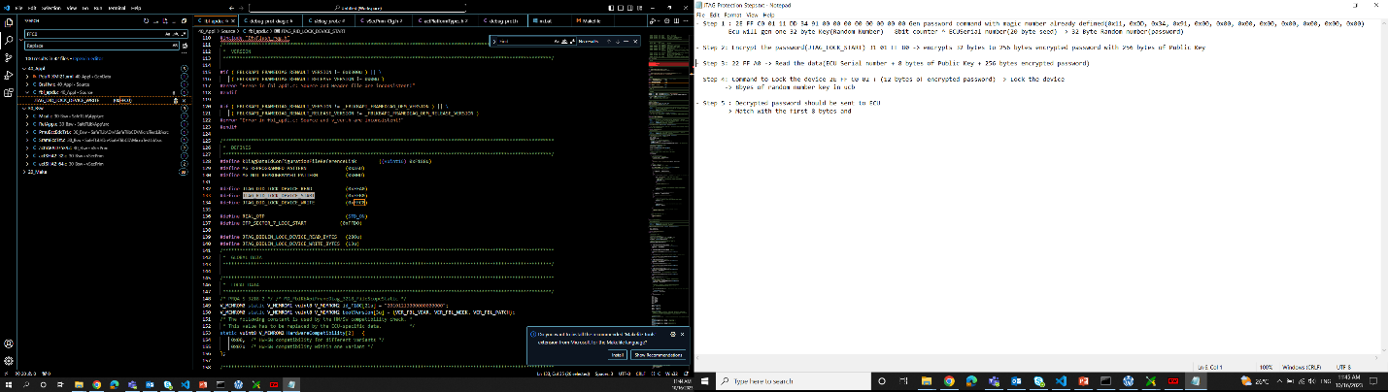

FBL compiling

K drive -> m in cmd(20make)

m to build

b to rebuild

In 20 make -> m.bat and Make file

In m.bat check for the compiler path



Also in Make file check for the compiler path

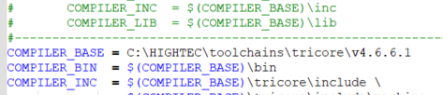

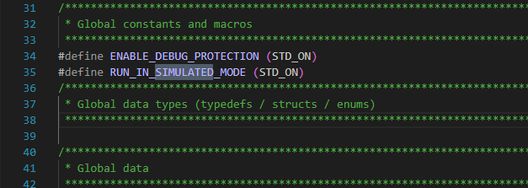

For JTAG Testing -> Turn **STD_ON** for the macro **RUN_IN_SIMULATED_MODE**